МИНОБОРНАУКИ РОССИИ

Федерального государственного бюджетного образовательное учреждение высшего образования

Костромской государственный университет

(КГУ)

Институт физико-математических и естественных наук

Кафедра защиты информации

Направление (профиль) 10.03.01 – Информационная безопасность

Дисциплина Базы Данных

**Отчет по лабораторной работе № 1**

Выполнила__________Смирнова Е.А.

гр. 17-ИБ-6

Проверил_________________ Волков А.А

Кострома, 2019 г

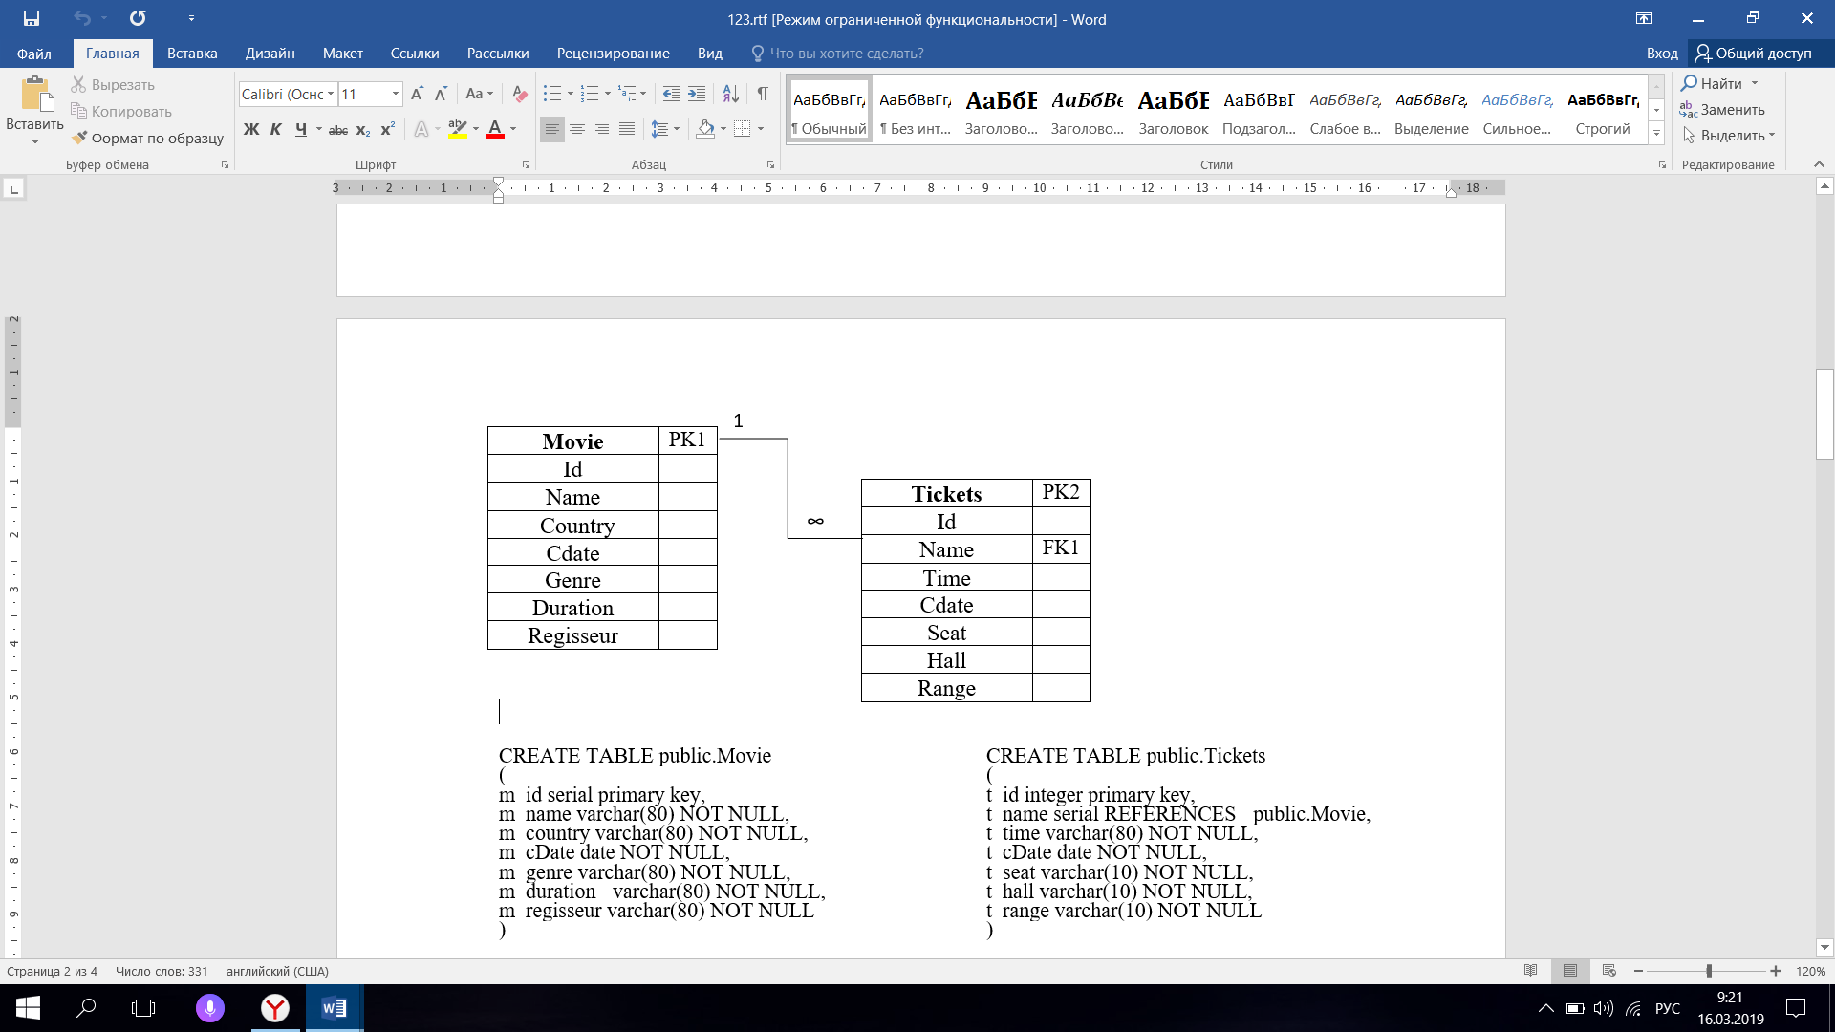

|  |  |
| --- | --- |
| CREATE TABLE public.Movie  (  m_id serial primary key,  m_name varchar(80) NOT NULL,  m_country varchar(80) NOT NULL,  m_cDate date NOT NULL,  m_genre varchar(80) NOT NULL,  m_duration varchar(80) NOT NULL,  m_regisseur varchar(80) NOT NULL  ) | CREATE TABLE public.Tickets  (  t_id integer primary key,  t_name serial REFERENCES public.Movie,  t_time varchar(80) NOT NULL,  t_cDate date NOT NULL,  t_seat varchar(10) NOT NULL,  t_hall varchar(10) NOT NULL,  t_range varchar(10) NOT NULL  ) |

1)

select M.m_name as name, M.m_country as country, M.m_cdate as cdate, M.m_genre as genre, M.m_duration as duration, M.m_regisseur as regisseur,

T.t_hall as hall, T.t_seat as seat, T.t_range as range

From Movie M, Tickets T

Where M.m_id = T.t_name and M.m_country ='США'

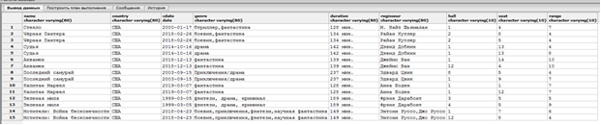

2)

select M.m_name, T.t_seat, T.t_hall, T.t_range, M.m_duration, T.t_time

From Movie M inner join Tickets T on M.m_id = T.t_name

Where M.m_genre = 'драма'

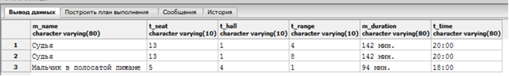

3) select M.m_name, T.t_seat, T.t_hall, T.t_range, M.m_duration, T.t_time

From Movie M full join Tickets T on M.m_id = T.t_name

Where M.m_duration = '127 мин.'

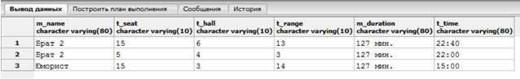

4) select M.m_name, T.t_seat, T.t_hall, T.t_range, M.m_duration, T.t_time

From Movie M left outer join Tickets T on M.m_id = T.t_name

Where T.t_hall = '1' and T.t_range = '7'

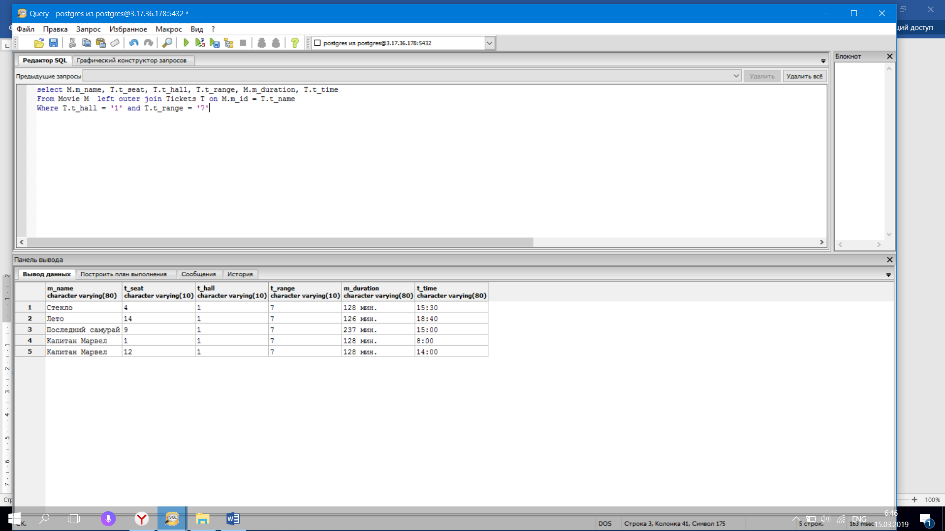

5) select M.m_name, Count(T.t_seat)

From Movie M left outer join Tickets T on M.m_id = T.t_name

Where T.t_hall = '1' and T.t_range = '7'

Group by M.m_name

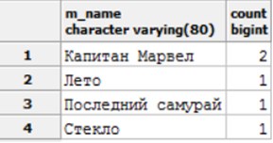

6) select M.m_name, Count(T.t_seat)

From Movie M left outer join Tickets T on M.m_id = T.t_name

Where T.t_hall = '1'

Group by M.m_name

Having Count(T.t_seat) = '2'

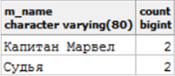

7) select M.m_name, Count(T.t_seat)

From Movie M left outer join Tickets T on M.m_id = T.t_name

Where T.t_range = '7'

Group by M.m_name

Having Count(T.t_seat) = '1'

Order by M.m_name ASC

